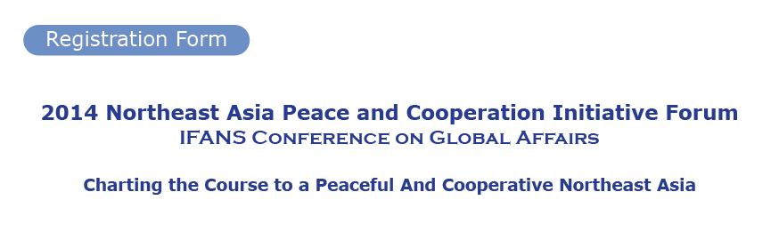
To participate in the Forum, please fill out the registration form and email it to the Forum Secretariat at 2014napci@mofa.go.kr, by Oct. 22(Wed).

※ On-site Registration is available for all sessions, except for the Opening Ceremony and Plenary Session.

1. Personal Information
First Name |  | Last Name
Nationality |  | Passport Number/  Diplomatic ID
Phone Number |  | Passport Number/  Diplomatic ID
Organization
/Company
Department |  | Job Title
E-mail Address
Postal Address
※ Personal information submitted to the Secretariat
will be used exclusively for the registration purpose of this forum.

2. Check the session(s) that you would like to attend. (Oct. 28)
Opening Ceremony | Yes ( )/No ( )
Plenary Session | Yes ( )/No ( )
Luncheon(12:00~13:30) | Yes ( )/No ( )
Session 1: Nuclear Safety and Other Nuclear Issues | Yes ( )/No ( )
Session 2: Energy Security | Yes ( )/No ( )
Session 3: Cyberspace | Yes ( )/No ( )

